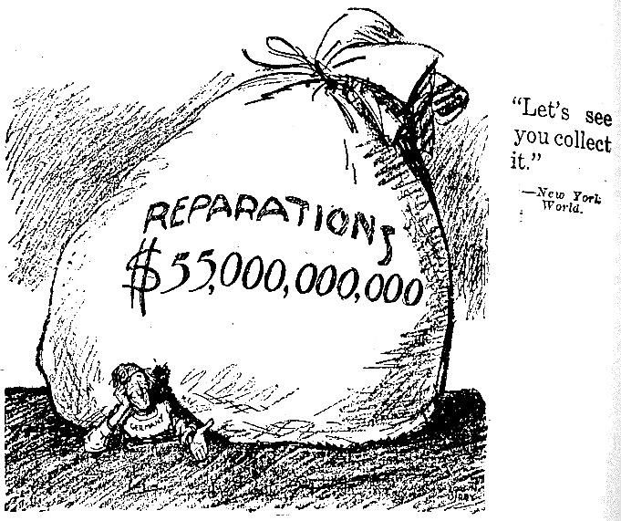
DOCUMENT 1
selected points from Woodrow Wilson's Fourteen Points (Jan.,1918)
1) Open covenants of peace, openly arrived at, after which there shall be no private international understandings of any kind but diplomacy shall proceed always frankly and in the public view
3) The removal, so far possible, of all economic barriers....
6) The evacuation of all Russian territory and such a settlement of all questions affecting Russia as will secure the best and freest cooperation of the other nations of the world in obtaining for her an unhampered and unembarrassed opportunity for the independent determination of her own political development and national policy and assure her of a sincere welcome into the society of free nations under institutions of her own choosing; and more than a welcome, assistance also of every kind that she may need and may herself desire.
Questions:
- How did President Wilson hope to support Russia?
- Do you think Wilson’s ideas would help preserve the peace and make Europe a better place?

DOCUMENT 2
National aspirations must be respected; people may now be dominated and governed only by their own consent. "Self determination" is not a mere phrase. It is an imperative principle of action, which statesmen will henceforth ignore at their peril. This war had its roots in the disregard of the rights of small nations and of nationalities which lacked the union and the force to make good their claim to determine their own allegiances and their own forms of political life. Covenants (Agreements) must now be entered into which will render such things impossible for the future; and those covenants must be backed by the united force of all nations that love justice and are willing to maintain it at any cost...
excerpt from speech by Woodrow Wilson to Congress
Feb.11, 1919
- How would this idea of Wilson benefit the minority populations (Slavs, Poles, Serbs, etc.) existing within European countries?

DOCUMENT 3
The Treaty includes no provision for the economic rehabilitation of Europe - nothing to make the defeated Central Powers into good neighbors, nothing to stabilize the new States of Europe, nothing to reclaim Russia; nor does it promote in any way a compact of economic solidarity amongst the Allies themselves; no arrangement was reached at Paris for restoring the disordered finances of France and Italy, or to adjust the systems of the Old World and the New.
Source: John Maynard Keynes, The Economic Consequences of Peace, 1920.
- What economic problems were not solved with the Versailles Treaty?
DOCUMENT 4
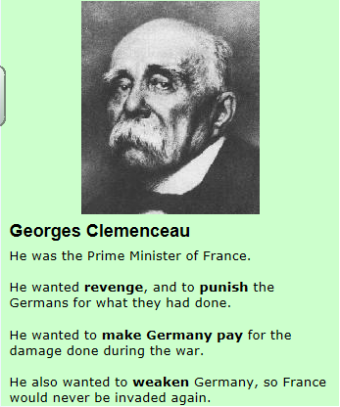
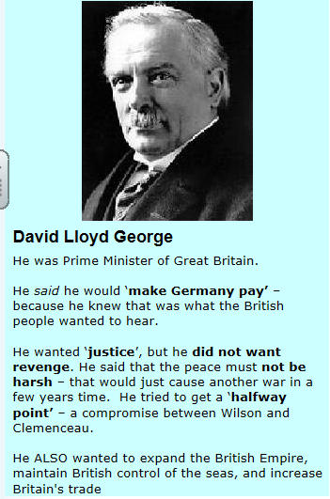

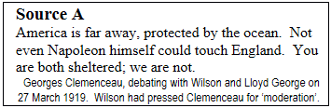
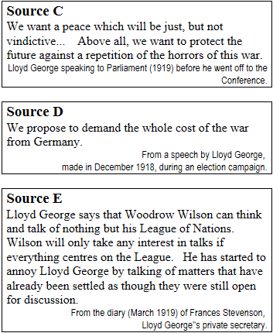

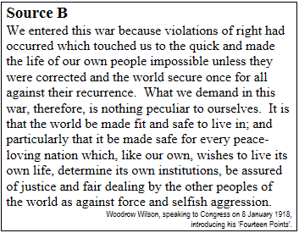

5. Why do you think Clemenceau wants to punish Germany so much? Do you think his arguments are valid? Will these ideas help ensure peace?

6. There seems to be a contradiction in source C and D above. What is the contradiction? Can said

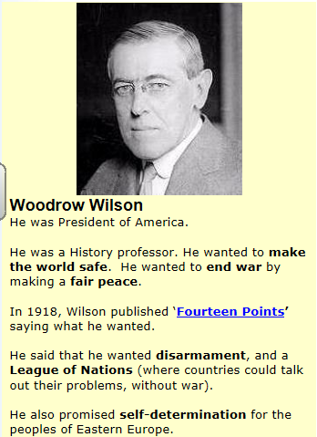
7. How do Wilson’s goals differ from Clemenceau’s goals? Would they help ensure peace?

DOCUMENT 5- Political Cartoon
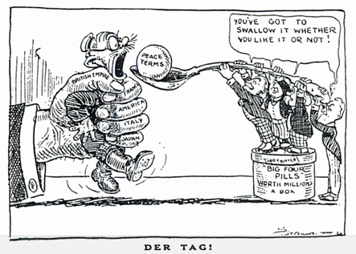
8. Explain the comic above. Who is being forced to swallow the pill? Who is doing the forcing?

DOCUMENT 6 (European Economic Graphs)
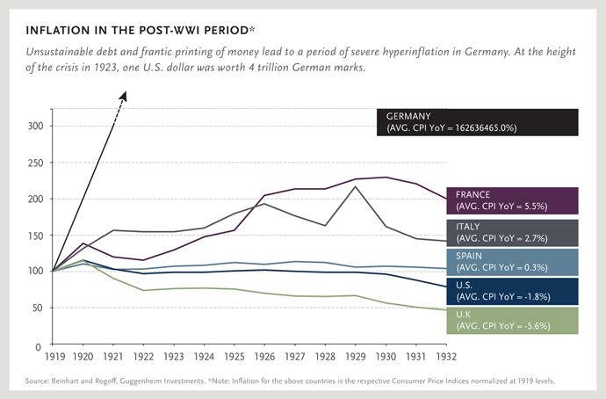
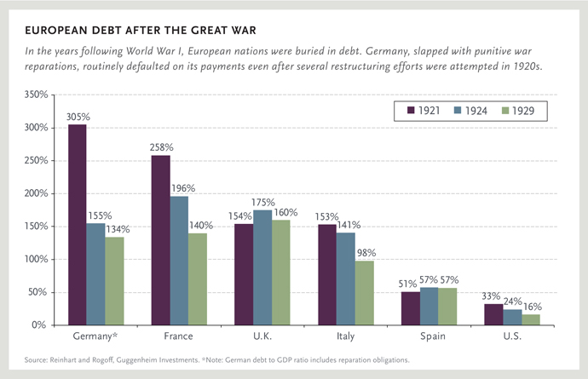

9: According to the graphs above, which countries emerge from WWI in the best economic shape? Which country is in the worst economic shape?

DOCUMENT 7: German Photographs
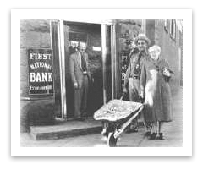
This German couple is carting their German Marks around in a wheel barrow.
Question: Why would they do that?

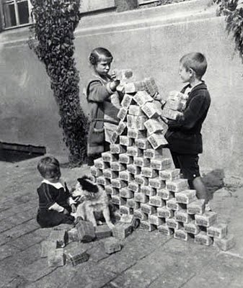
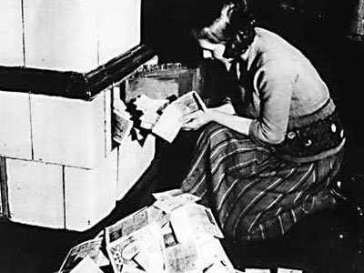
Above: Wheel barrow full of money; children are stacking German Marks like building blocks while the woman at the right is loading Marks in the furnace.
10. Question: How do these images support the data in the graphs on the previous page?
Document 8 Treaty of Versailles (June 28, 1919)
Read each provision below and decide whether it supports peace and helps Europe recover from the war or not.
Article 22. Certain communities formerly belonging to the Turkish Empire have reached a stage of development where their existence as independent nations can be recognized with the assistance of a Western power until such time as they are able to stand alone.
Supports peace and recovery because | Does not support peace and recovery because

Alsace-Lorraine:
Article 51. The territories which were ceded to Germany on February 26, 1871 [Franco-Prussian War], andthe Treaty of Frankfort of May 10, 1871, are restored to French sovereignty as from the date of the Armisticeof November 11, 1918.
Supports peace and recovery because | Does not support peace and recovery because

Article 119. Germany renounces in favor of the Principal Allied Powers all her rights and titles over her overseas possessions.
Supports peace and recovery because | Does not support peace and recovery because

Article 156. Germany renounces, in favour of Japan, all her rights and title[Chinese colonies]…which she acquired in virtue of` the Treaty concluded by her with China on March 6, 1898 [Treaty System]
Supports peace and recovery because | Does not support peace and recovery because

Article 159. The German military forces shall be demobilised and reduced as follows
Supports peace and recovery because | Does not support peace and recovery because

Article 160. By a date which must not be later than March 31, 1920, the German Army must not comprise more than seven divisions of infantry and three divisions of cavalry.
The Army shall be devoted exclusively to the maintenance of order within the territory and to the control of the frontiers.
Supports peace and recovery because | Does not support peace and recovery because

Article 231. Germany accepts the responsibility of Germany and her allies for causing all the loss and damage to which the Allied Governments have been subjected as a consequence of the war imposed upon them by the aggression of Germany and her allies.
Supports peace and recovery because | Does not support peace and recovery because

Article 232. The Allied Governments recognize that the resources of Germany are not adequate to make complete reparation for all such loss and damage, however, they require that Germany will make compensation for all damage done to the civilian population of the Allied Powers and to their property during the period of the war.
Supports peace and recovery because | Does not support peace and recovery because

Support IN FAVOR of the Treaty of Versailles | Support AGAINST the Treaty of Versailles
Moodle: Was the Treaty of Versailles a good settlement to ensure the peace and help Europe recover from the war?

