Take Home Essays. Using notes, graphs homework resources, answer the following questions thoroughly.
1. The Roaring 20s marked a time period of increasingly rash behaviors by individuals from all facets of society. Explain the origins of these behaviors, their catalysts, and net results of actions/activities by the end of the decade.
Consider WWI, prohibition, women’s suffrage and celebrities in your answer.

2. At the conclusion of WWI, the US political atmosphere “Returned to Normalcy” with regards to economic and international values. What pro-business and isolationist attitudes reoccurred?
Consider political leaders, economic buzzwords (tariff, laissez-faire), anti-foreigner resentment

3. What are the origins of the Stock Market Crash of 1929? From a graph/statistical point of view, how bad was the recession of 1929-1933?
Consider weaknesses in the economy, stock price manipulation and banking sector participation, graphs/data given in class.

4. How did FDR combat the Great Depression? Were his programs successful in defeating the economic malaise of the 1930s and ‘40s?
Consider psychology (…fear itself), 3 Rs programs (don’t need all of the alphabet soup), GDP and consumer spending.

- Excerpt –The Great Gatsby -- https://ebooks.adelaide.edu.au/f/fitzgerald/f_scott/gatsby/chapter3.html

Chapter 3
There was music from my neighbor’s house through the summer nights. In his blue gardens men and girls came and went like moths among the whisperings and the champagne and the stars. At high tide in the afternoon I watched his guests diving from the tower of his raft, or taking the sun on the hot sand of his beach while his two motor-boats slit the waters of the Sound, drawing aquaplanes over cataracts of foam. On week-ends his Rolls-Royce became an omnibus, bearing parties to and from the city between nine in the morning and long past midnight, while his station wagon scampered like a brisk yellow bug to meet all trains. And on Mondays eight servants, including an extra gardener, toiled all day with mops and scrubbing-brushes and hammers and garden-shears, repairing the ravages of the night before.
Every Friday five crates of oranges and lemons arrived from a fruiterer in New York — every Monday these same oranges and lemons left his back door in a pyramid of pulpless halves. There was a machine in the kitchen which could extract the juice of two hundred oranges in half an hour if a little button was pressed two hundred times by a butler’s thumb.
At least once a fortnight a corps of caterers came down with several hundred feet of canvas and enough colored lights to make a Christmas tree of Gatsby’s enormous garden. On buffet tables, garnished with glistening hors-d’oeuvre, spiced baked hams crowded against salads of harlequin designs and pastry pigs and turkeys bewitched to a dark gold. In the main hall a bar with a real brass rail was set up, and stocked with gins and liquors and with cordials so long forgotten that most of his female guests were too young to know one from another.
By seven o’clock the orchestra has arrived, no thin five-piece affair, but a whole pitful of oboes and trombones and saxophones and viols and cornets and piccolos, and low and high drums. The last swimmers have come in from the beach now and are dressing up-stairs; the cars from New York are parked five deep in the drive, and already the halls and salons and verandas are gaudy with primary colors, and hair shorn in strange new ways, and shawls beyond the dreams of Castile. The bar is in full swing, and floating rounds of cocktails permeate the garden outside, until the air is alive with chatter and laughter, and casual innuendo and introductions forgotten on the spot, and enthusiastic meetings between women who never knew each other’s names.
The lights grow brighter as the earth lurches away from the sun, and now the orchestra is playing yellow cocktail music, and the opera of voices pitches a key higher. Laughter is easier minute by minute, spilled with prodigality, tipped out at a cheerful word. The groups change more swiftly, swell with new arrivals, dissolve and form in the same breath; already there are wanderers, confident girls who weave here and there among the stouter and more stable, become for a sharp, joyous moment the centre of a group, and then, excited with triumph, glide on through the sea-change of faces and voices and color under the constantly changing light.
Suddenly one of the gypsies, in trembling opal, seizes a cocktail out of the air, dumps it down for courage and, moving her hands like Frisco, dances out alone on the canvas platform. A momentary hush; the orchestra leader varies his rhythm obligingly for her, and there is a burst of chatter as the erroneous news goes around that she is Gilda Gray’s understudy from the Follies. The party has begun.

- Cartoon – “Fungus” from Brooklyn Eagle. Circa 1919
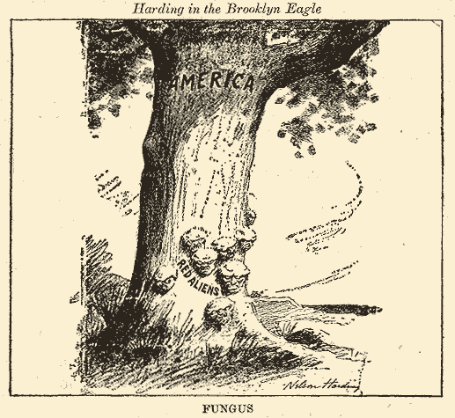

- Graphs – From class!
http://sjosocialstudies.weebly.com/roaring-20sgreat-depression.html

- Excerpt from speech – FDR Inaugural. March 4, 1933

I am certain that my fellow Americans expect that on my induction into the Presidency I will address them with a candor and a decision which the present situation of our Nation impels. [ See APP note, below.] This is preeminently the time to speak the truth, the whole truth, frankly and boldly. Nor need we shrink from honestly facing conditions in our country today. This great Nation will endure as it has endured, will revive and will prosper. So, first of all, let me assert my firm belief that the only thing we have to fear is fear itself—nameless, unreasoning, unjustified terror which paralyzes needed efforts to convert retreat into advance. In every dark hour of our national life a leadership of frankness and vigor has met with that understanding and support of the people themselves which is essential to victory. I am convinced that you will again give that support to leadership in these critical days

