Mr. Beckett
Potawatomi Trail of Death

Principals – Who are the following people/groups?
http://www.usd116.org/mfoley/trail/trail.html

Potawatomi –

Grant Winter –

General John Tipton –

Ashkum –
How is he remembered in Illinois?

Father Petit –
Why is he here?

The Story

What federal act allowed for the Potawatomi to be removed from Indiana to Kansas?

How did General Tipton ensure the Native Americans would not resist the army?

What initial step did the army take to force the Potawatomi to leave their homes?

Using eyewitness accounts, generally observe what happened to the Potawatomi as they are moved from Indiana to Kansas.
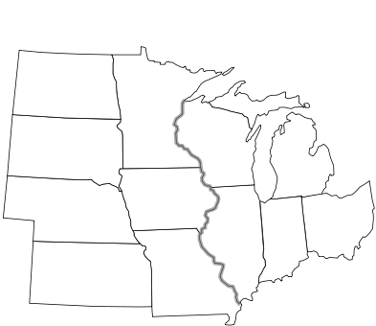

Copy and paste 3 monument pics of the Trail of Death and place their correct geography on the map. Write their locations (city/state) below

1.

2.

3.

