Document 1
That this kingdom has the sovereign, the supreme legislative power over America, is granted. It cannot be denied; and taxation is a part of that sovereign power. It is one branch of the legislation. . . . Protection and obedience are reciprocal. Great Britain protects America, America is bound to yield [give] obedience. If not, tell me when the Americans were emancipated? When they want the protection of this kingdom, they are always ready to ask it. That protection has always been afforded them in the most full and ample manner. The nation has run itself into an immense debt to give them this protection; and now they are called upon to contribute a small share to the public expense.
—George Grenville, Member of Parliament (January 14, 1766)

Document 2
If I was in any doubt, as to the right which the Parliament of Great Britain had to tax us without our consent, I should most heartily coincide with you in opinion, that to petition, and petition only, is the proper method to apply for relief; because we should then be asking a favor, and not claiming a right, which, by the law of nature and our constitution, we are, in my opinion, indubitably entitled to. I should even think it criminal to go farther than this, under such an idea; but none such I have. I think the Parliament of Great Britain hath no more right to put their hands into my pockets, without my consent, than I have to put my hands into yours for money; and this being already urged to them in a firm, but decent manner, by all the colonies, what reason is there to expect anything from their justice?
—George Washington, letter to Bryan Fairfax (July 20, 1774)

Document 3
Here then, my dear countrymen ROUSE* yourselves, and
behold the ruin hanging over your heads. If you ONCE admit,
that Great-Britain may lay duties upon her exportations* to us,
for the purpose of levying* money on us only, she then will have
nothing to do, but to lay those duties on the articles which she
prohibits us to manufacture- and the tragedy of American liberty
is finished . . . If Great-Britain can order us to come to her for
necessaries we want, and can order us to pay what taxes she
pleases before we take them away, or when we land them
here, we are as abject* slaves…

- John Dickinson Letters from a Farmer

Picture #1 -- Paul Revere Engraving
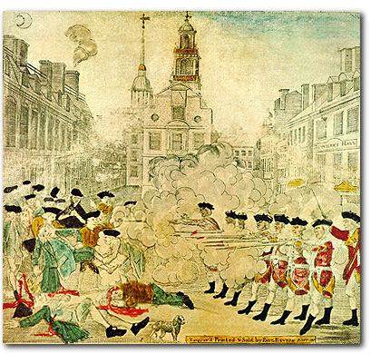

Picture #2 – Tar and Feathering a British Customs Official
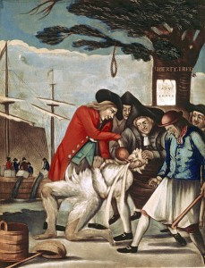

Document 4

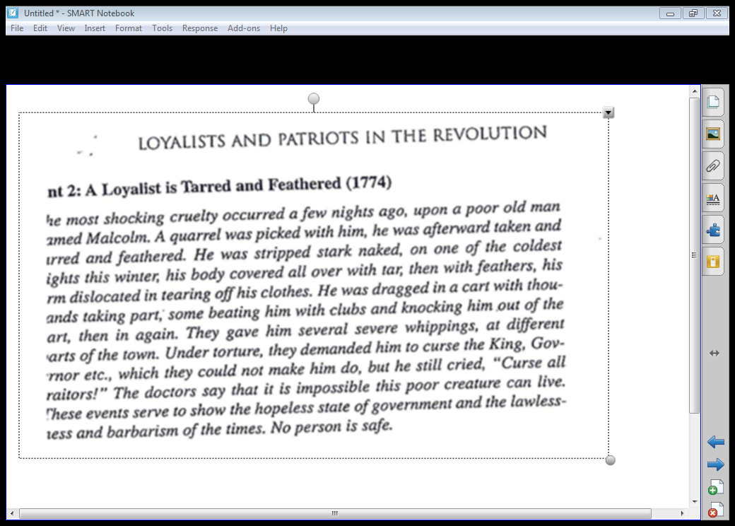

Document #4
The tea destroyed was contained in three ships, lying near each other at … Griffin's wharf, and were surrounded by armed ships of war…
It was now evening, and I immediately dressed myself in the costume of an Indian, equipped with a small hatchet… and a club, after having painted my face and hands with coal dust in the shop of a blacksmith, I repaired to Griffin's wharf, where the ships lay that contained the tea.
When I first appeared in the street after being thus disguised, I fell in with many who were dressed, equipped and painted as I was, and who fell in with me and marched in order to the place of our destination.
When we arrived at the wharf, … they divided us into three parties, for the purpose of boarding the three ships which contained the tea ... as soon as we were on board the ship … [they] ordered me to go to the captain and demand of him the keys to the hatches and a dozen candles. I made the demand accordingly, and the captain promptly replied, and delivered the articles; but requested me at the same time to do no damage to the ship or rigging.
We then were ordered by our commander to open the hatches and take out all the chests of tea and throw them overboard, and we immediately proceeded … first cutting and splitting the chests with our tomahawks, so as thoroughly to expose them to the effects of the water.
In about three hours from the time we went on board, we had thus broken and thrown overboard every tea chest to be found in the ship, while those in the other ships were disposing of the tea in the same way, at the same time. We were surrounded by British armed ships, but no attempt was made to resist us…
-- George Hewes

Picture 3.
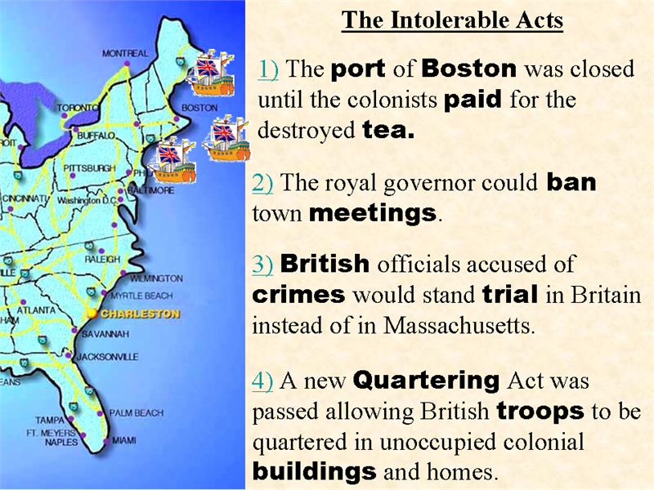

Documents/Pictures | Pro/Anti British  Pro/Anti Colonists | Pro/Anti British ??? | Pro/Anti Colonist ???
Doc 1
Doc 2
Doc 3
Pic 1
Pic 2
Doc 4
Pic 3

